صورة تحتوي على نص, جهاز, متر

تم إنشاء الوصف تلقائياً

**Database Project**

**Name of Project :**

**Airline Reservation**

**Supervised By :**

**- Dr : Hanafy**

**Submitted By :**

**- Abdel Rahman Ghoniem Ghoniem Abdel Azim**

**- Mohammed Abdul Karim Mohammed Alammar**

**- Mohammed Abdel Motaleb Mohammed Shaaban**

**- Mohammed Ashraf Mohammed Abdel Aziz**

**- Omnia Mohamed Mostafa El Sadny**

Contents

Introduction: 3

report 6

MAPPING:- 8

RelationalDiagram**:-** 9

# Introduction:

**Airline Reservation**

**صورة تحتوي على نص, بطاقة عمل, قصاصة فنية

تم إنشاء الوصف تلقائياً**

**Description of the project:**

**Airline reservation system (ARS) are system that allow an airline to sell its inventory (seats).**

**It contains information on schedules and prices and contains a database of reservations (or passenger name records) and tickets issued.**

**The main drive behind establishing our project was our wish to develop the concept of traveling easily, comfortably and elegantly. This is why we have always strived to provide innovative online traveling solutions to travelers around Egypt and travelers from all over the world, middle eastern especially. We proud for provides comprehensive and high-quality services in the travel and tourism sector.**

**Consider the following set of requirements for an airline reservation system database.**

**1. Passenger information consists of several pieces of information. Each passenger is described by number, first and last name, bank account number, email, phone number, address, national identification number (unique) and passport number.**

**2. The aircraft was described by name (unique), model, seats and identity.**

**3. The airline is described by the name (unique).**

**4. The airport is described as (unique) and the city.**

**5. Payment is described by name and bank account number (unique).**

**6. Ticket information includes flight number, ticket number from location to location, arrival and departure time, ticket price, airport name, passport ID (unique) and cabin type.**

**7. Includes flight information, airline name, flight identifier (unique), aircraft identifier, flight identifier, arrival time, departure time, from location, to location.**

report**:-**

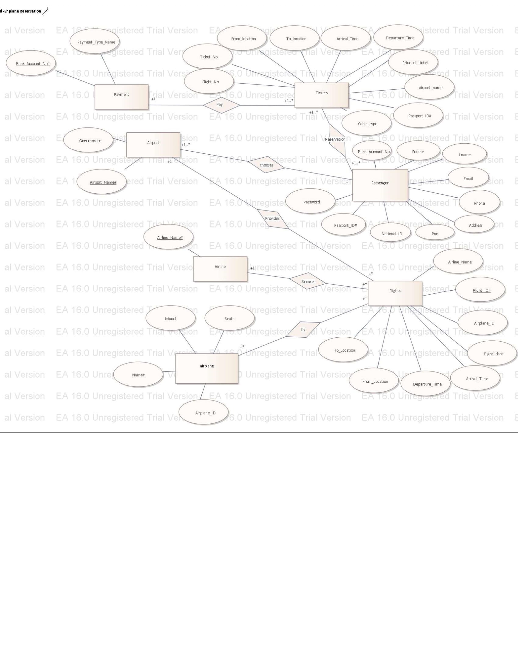**ER DIAGRAM:-**

# MAPPING:-

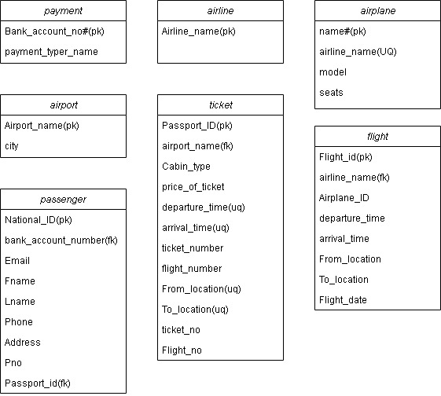

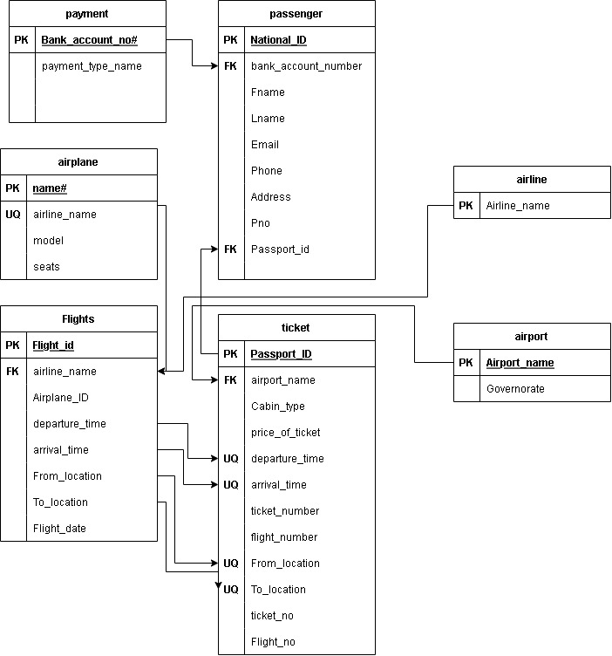RelationalDiagram**:-**

**Database Relationships and Tables with Sample Data:-**

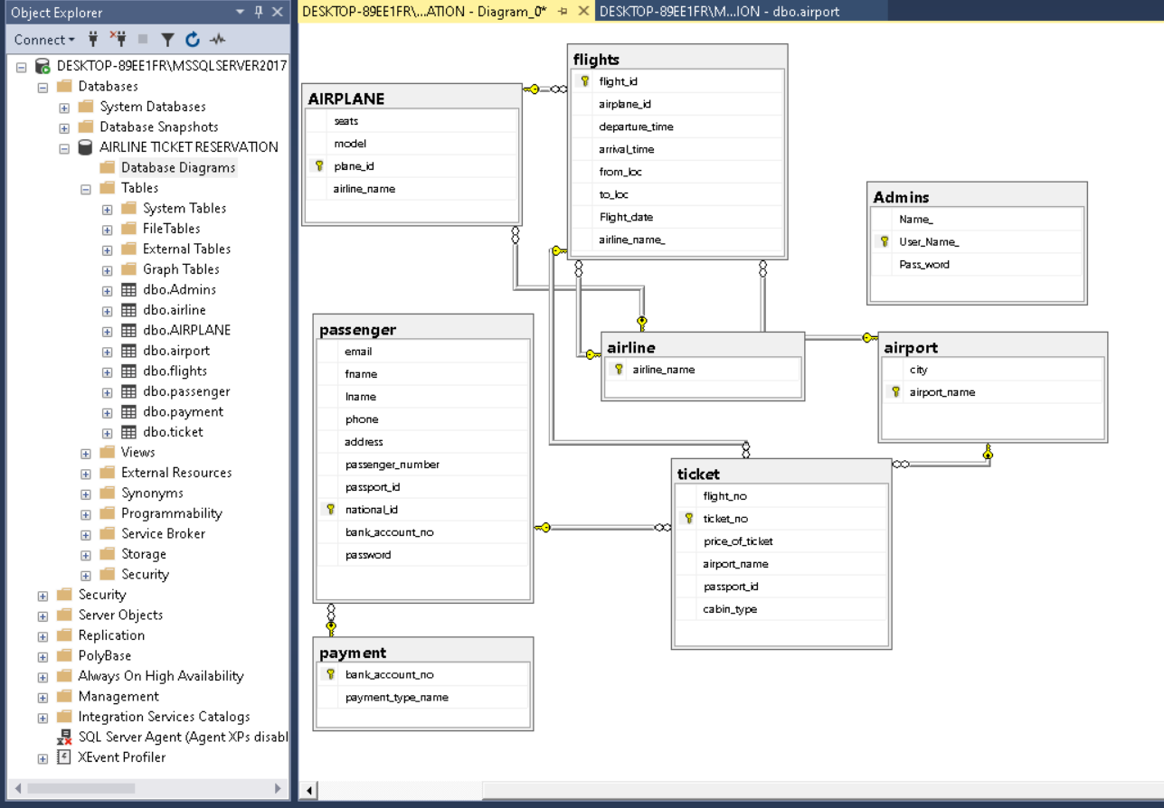

**Input / Output Interface Design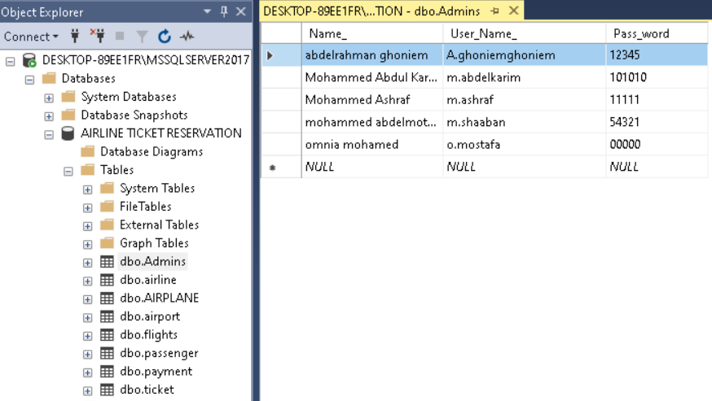:-**

**1-admins**

Admins not associated to all databases by a way it affects admins otherwise databases associated with admin in order for admins to grant access needed to manipulate the databases freely

**2-airline names**

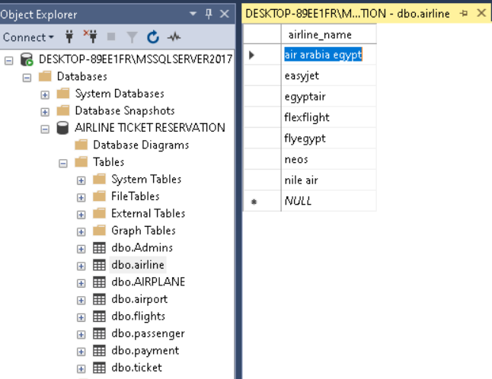

**3-airplanes**

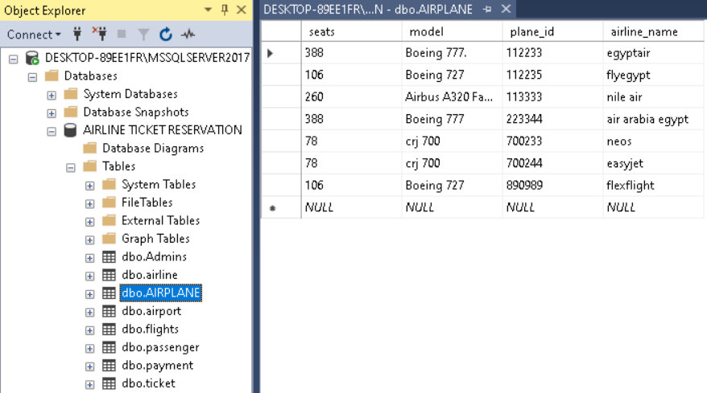

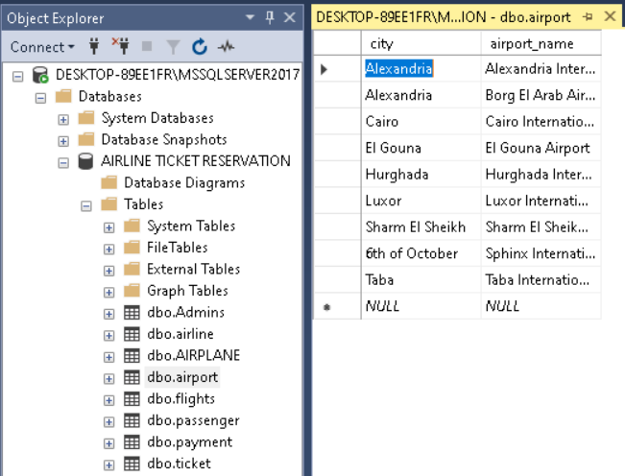**4-airport**

**5-flights**

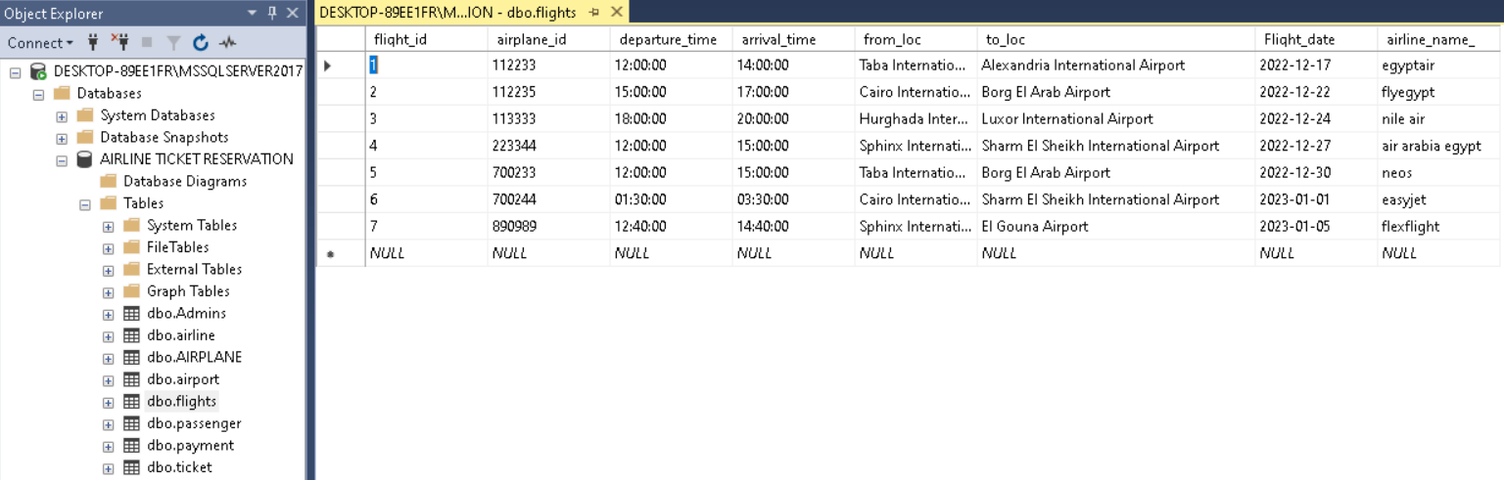

**6-passenger**

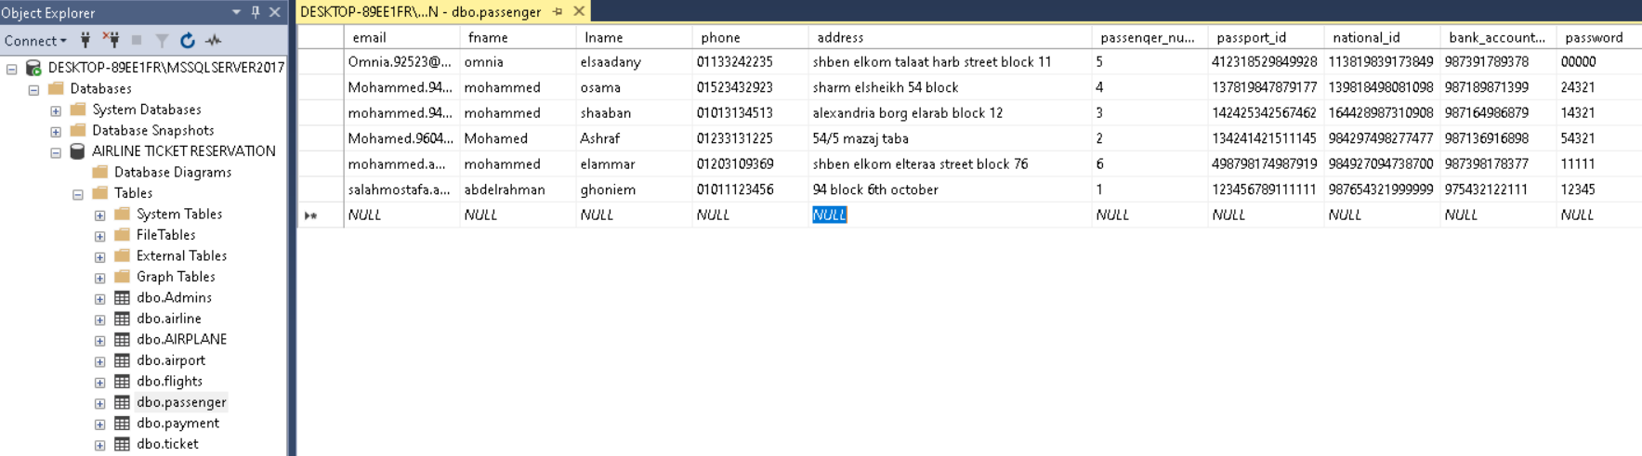

**7-payment**

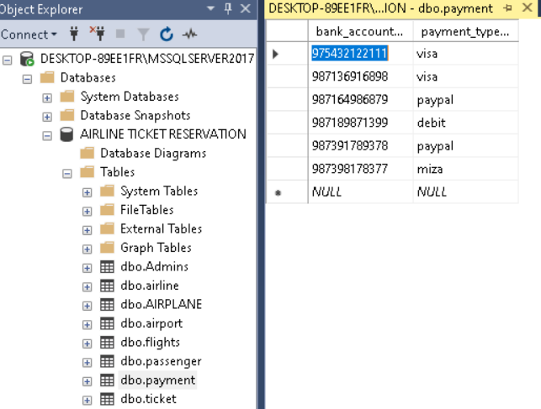

**8-ticket**

